This document displays all the snapshots of our Kanban board on Trello. We took regular snapshots to keep track of our rate of progress throughout the second sprint.

07.03.2024 – 15:18:

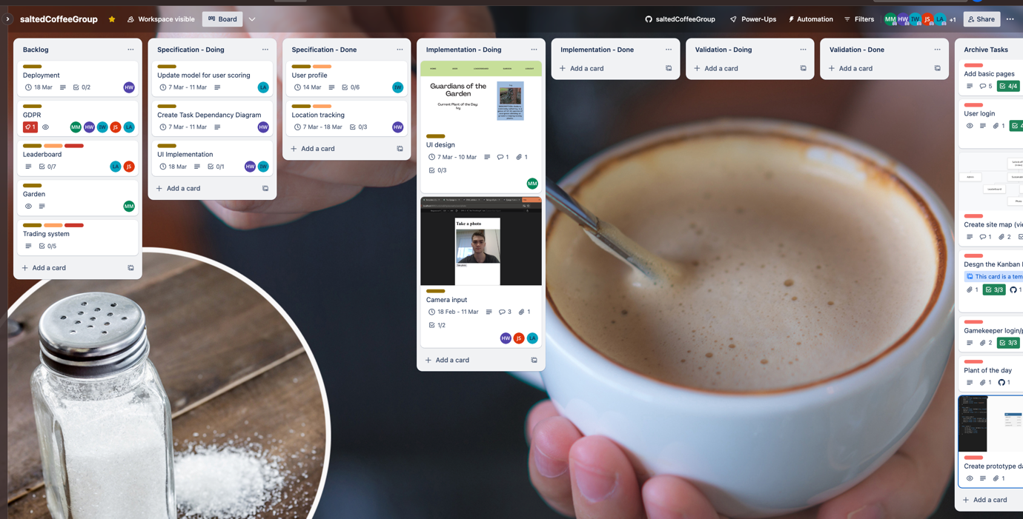

07.03.2024 – 15:38:

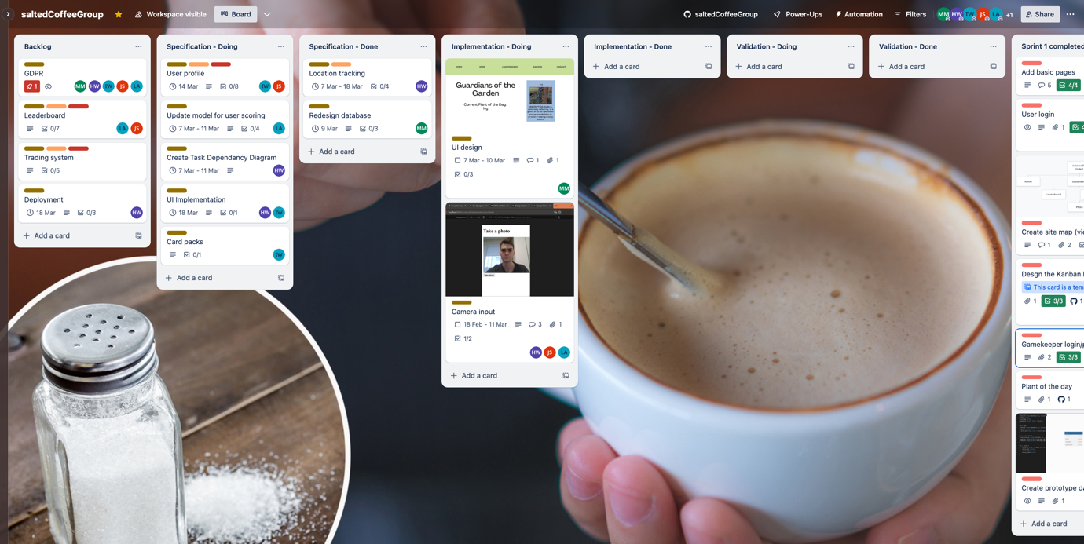

08.03.2024 – 18:42:

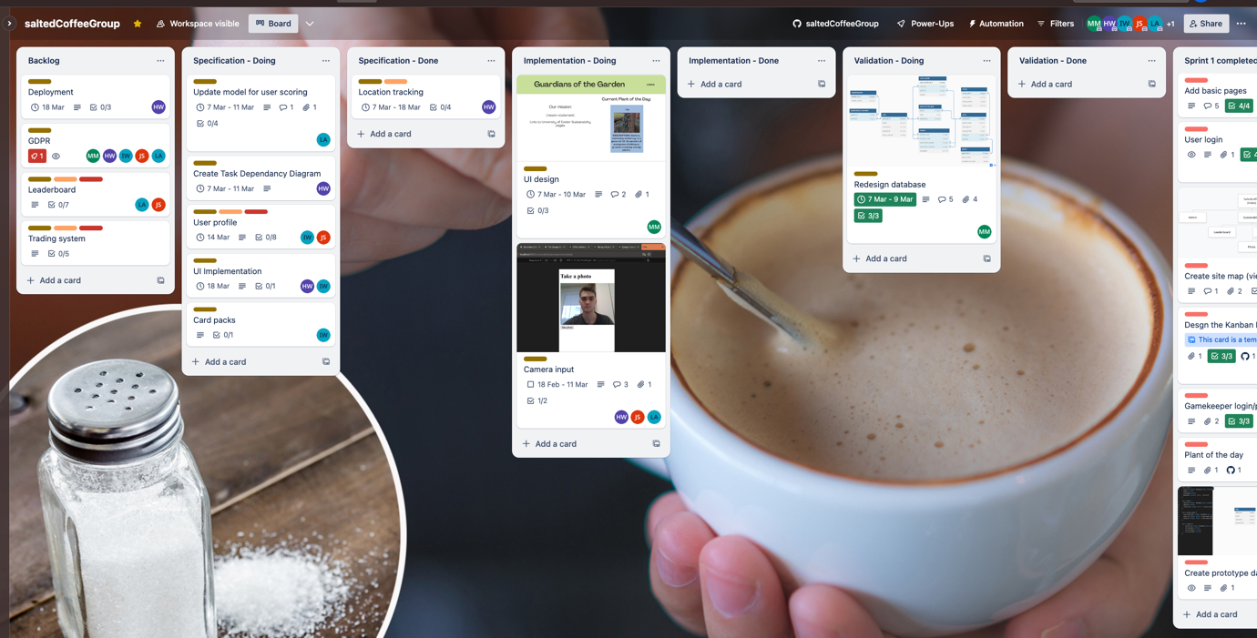

11.03.2024 – 12:58:

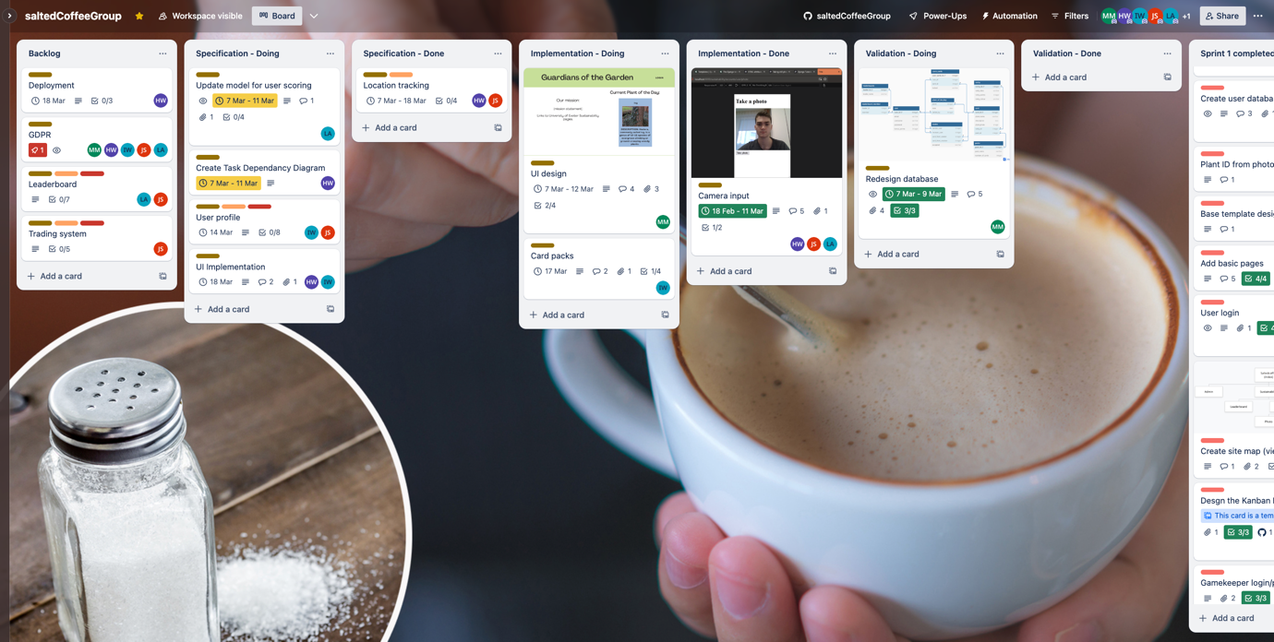

11.03.2024 – 14:45:

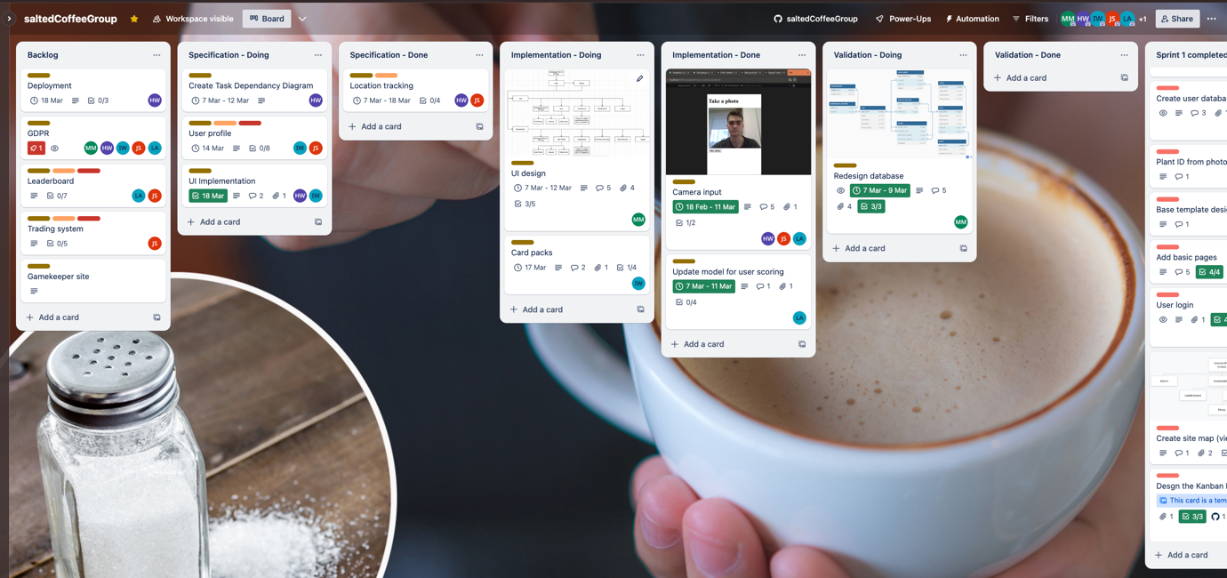

11.03.2024 – 18:59:

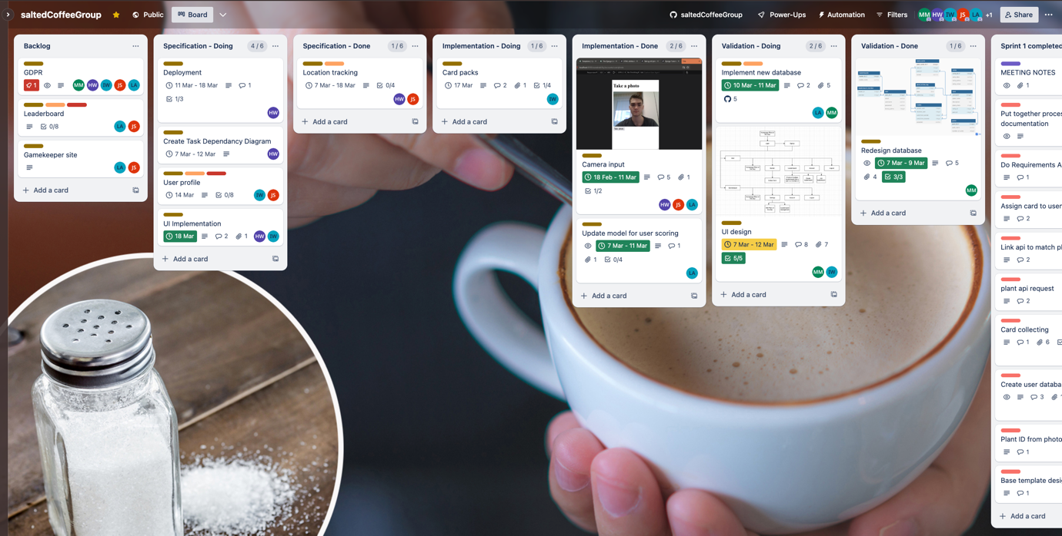

12.03.2024 – 17:37:

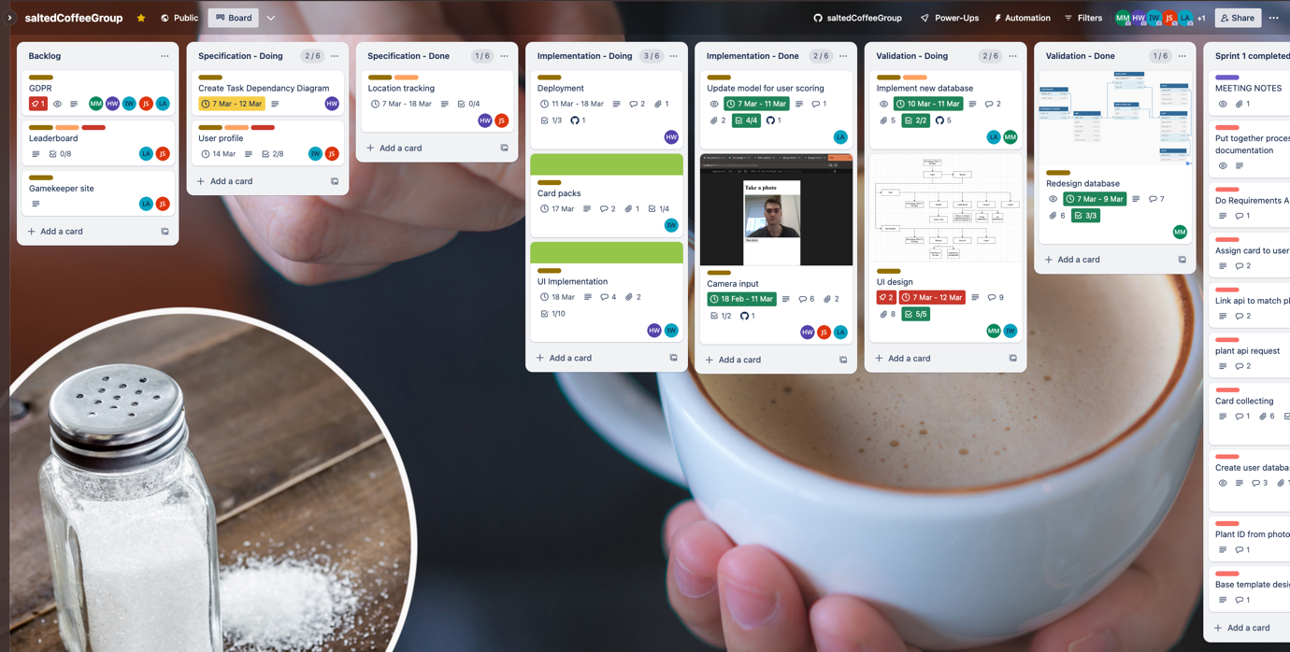

13.03.2024 – 09:18:

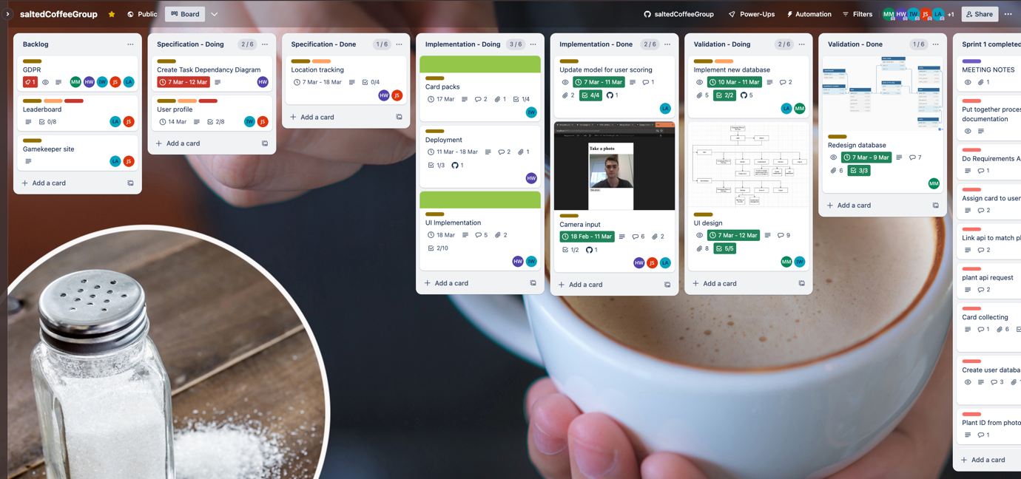

13.03.2024 – 13:26:

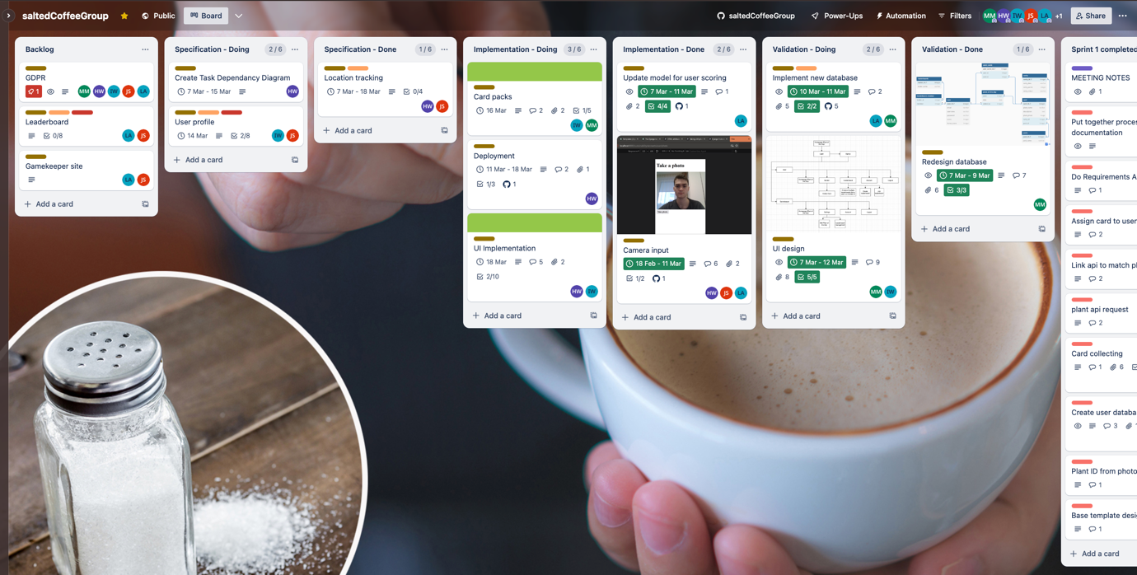

14.03.2024 – 14:53:

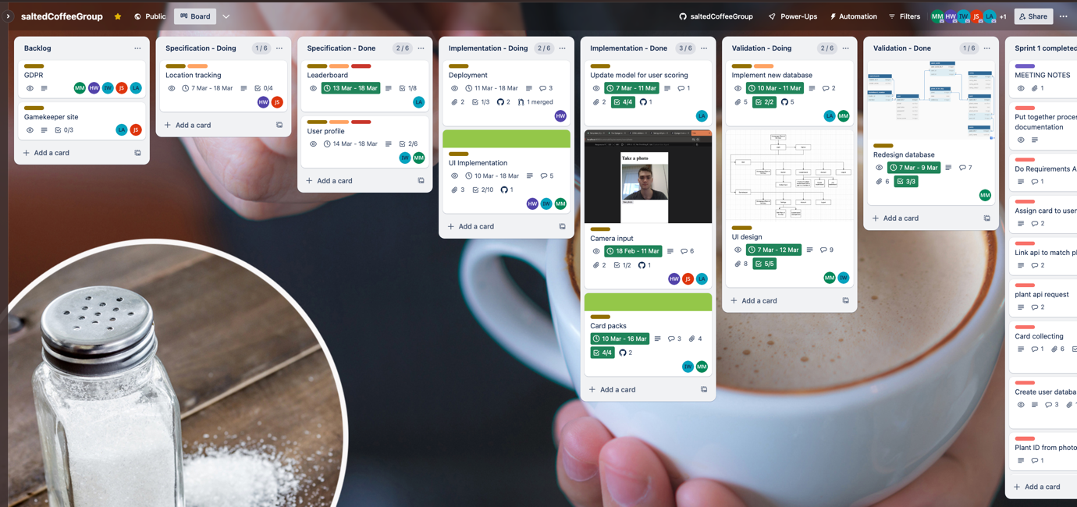

15.03.2024 – 13:19:

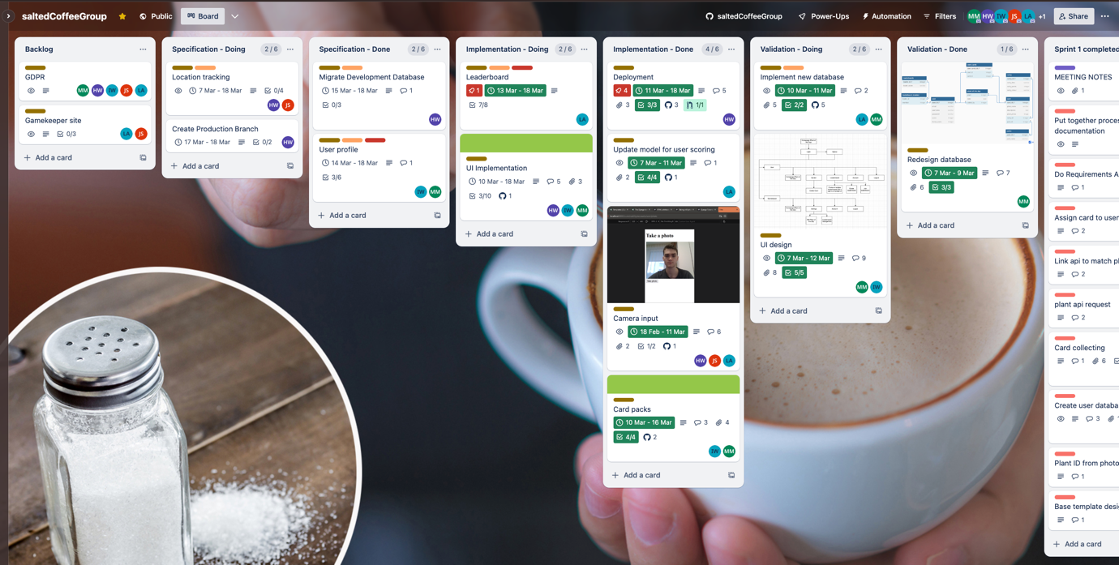

15.03.2024 – 13:20:

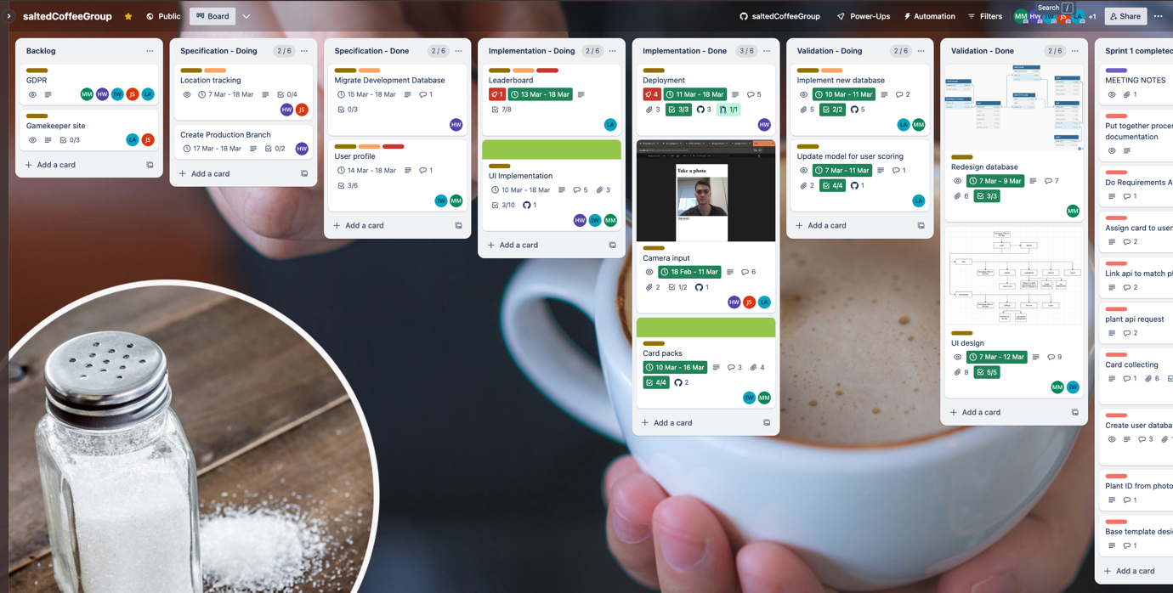

17.03.2024 – 13:03:

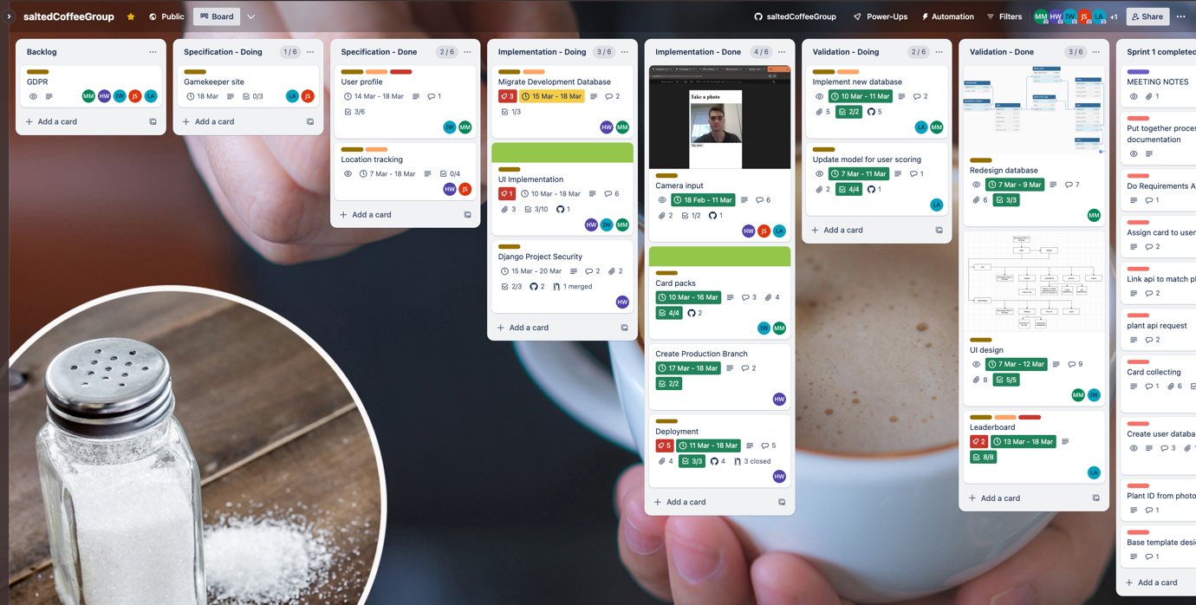

17.03.2024 – 13:04:

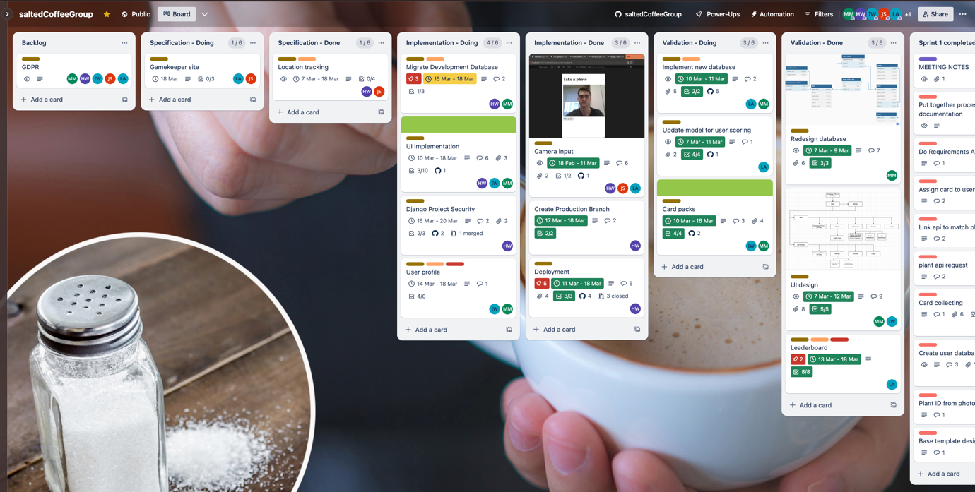

18.03.2024 – 14:20:

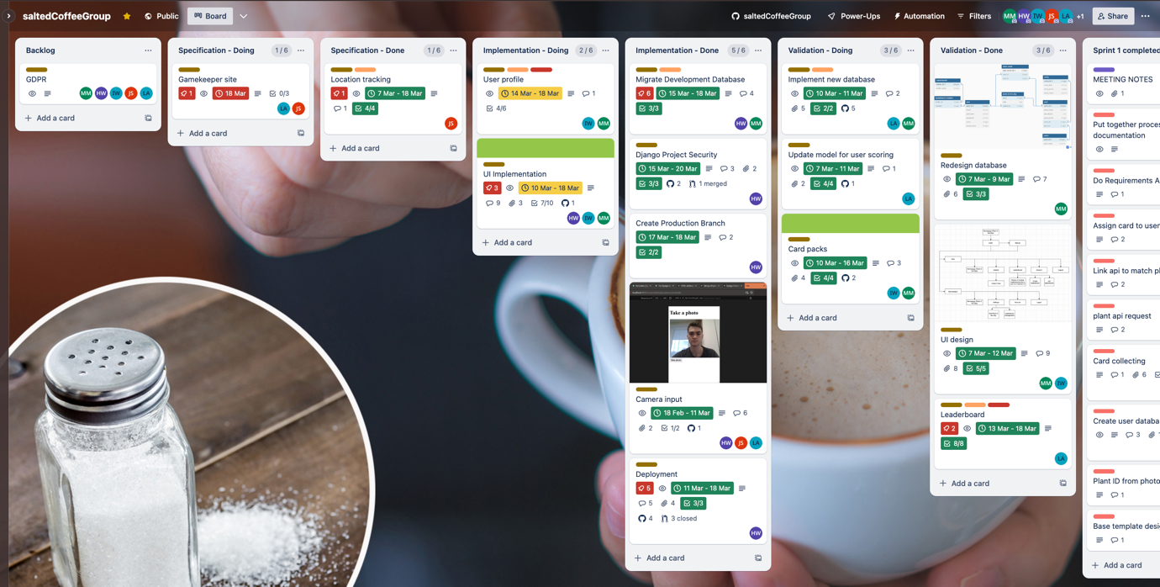

18.03.2024 – 14:22:

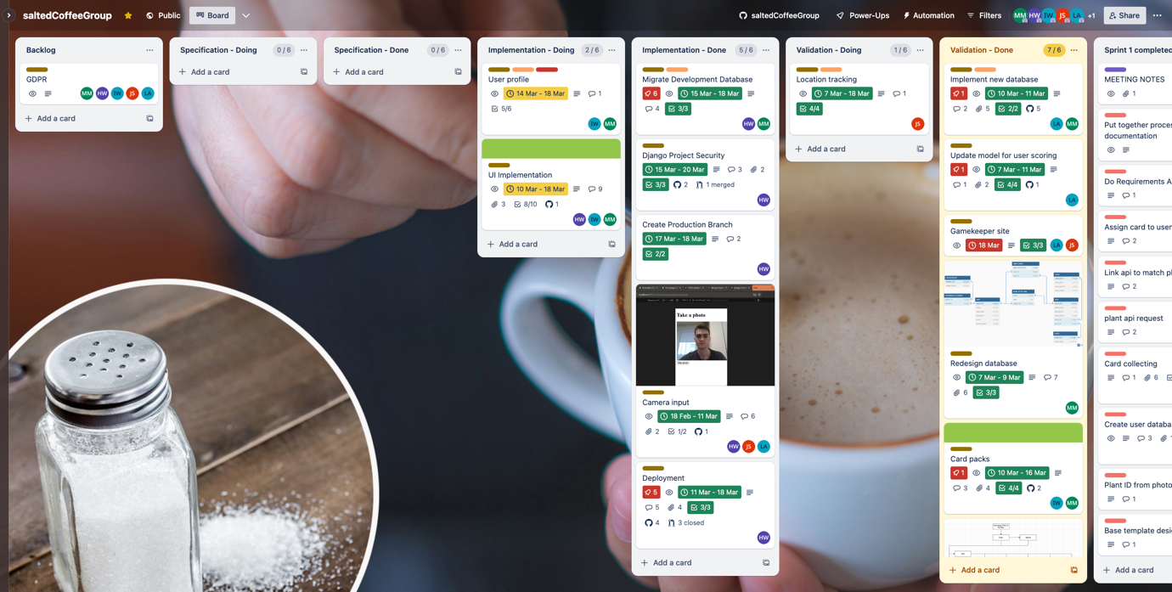

18.03.2024 – 14:23:

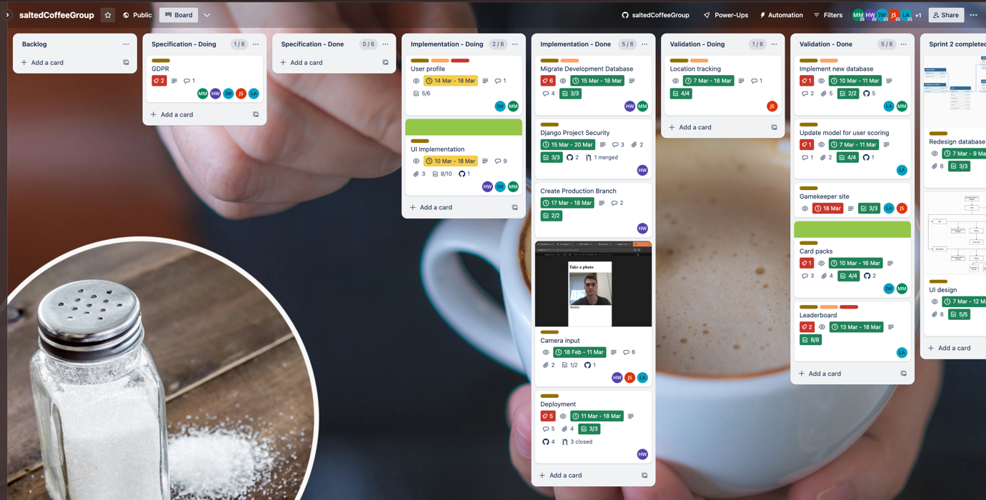

18.03.2024 – 14:26:

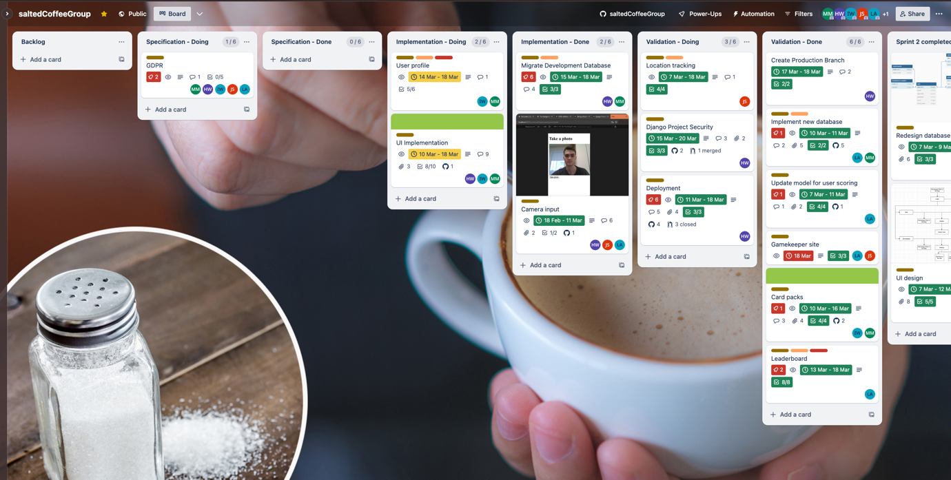

18.03.2024 – 14:48:

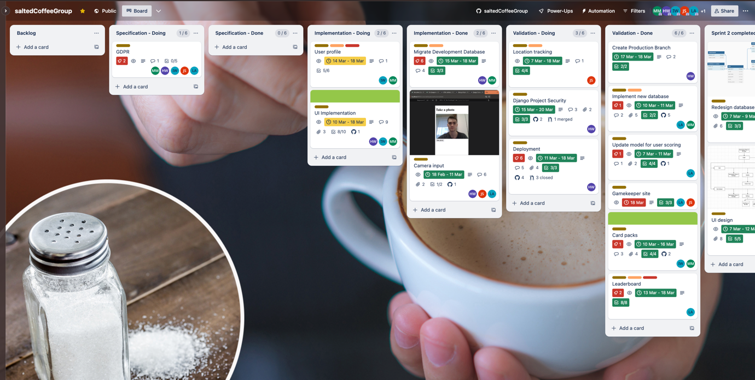

19.03.2024 – 13:03:

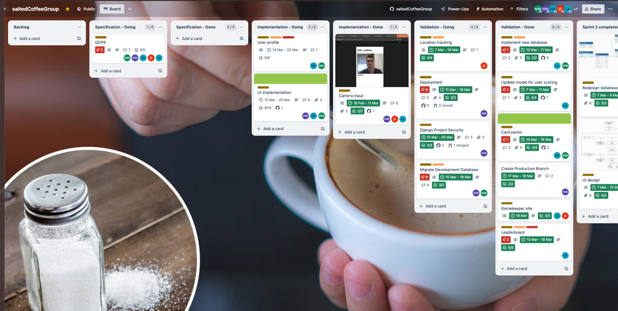

19.03.2024 – 15:41:

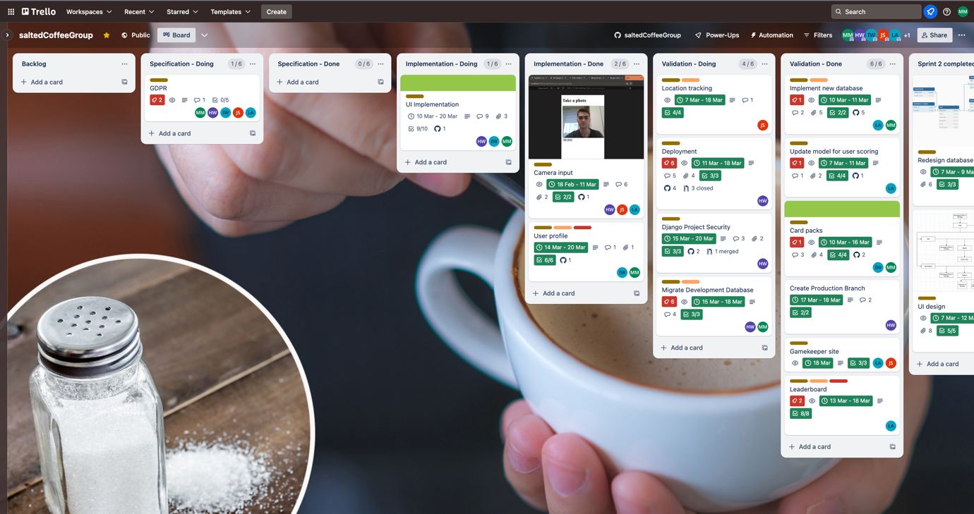

19.03.2024 – 20:45:

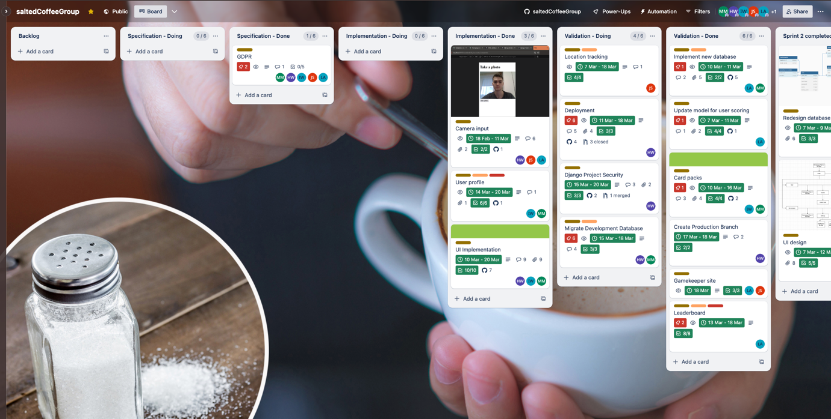

19.03.2024 – 20:59:

